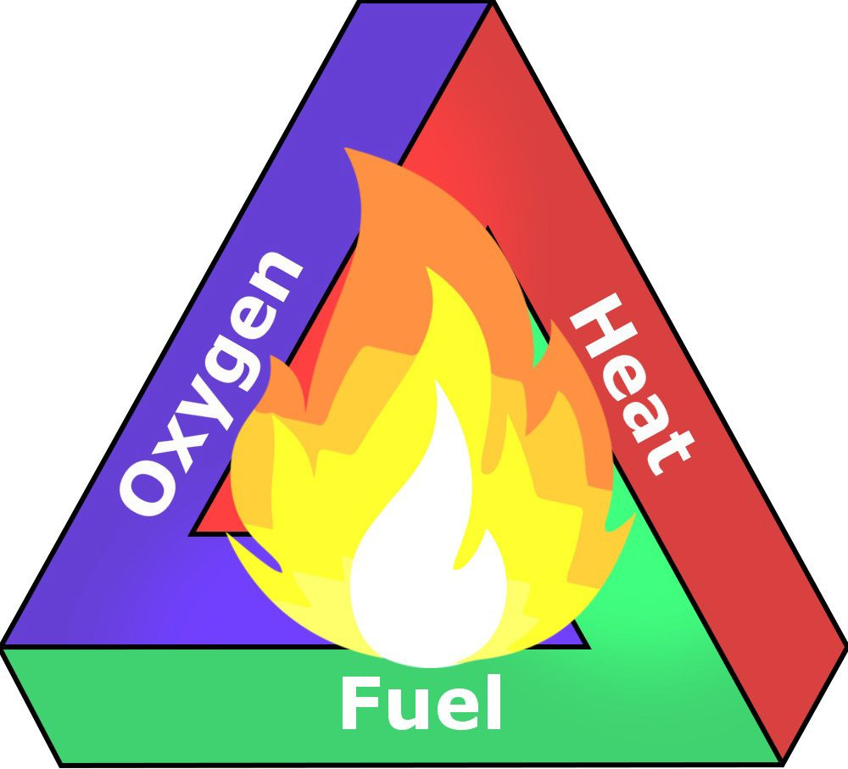

Remember local call emergency status

Regularly maintain equipment and vehicle

Bands around 3.9μm suitable for detecting fire

Affects for plants and animals, Human beings

These are allows important nutrients to return to soil

Enabling healthy beginning for plants and animals

Respiratory issues

Fires eliminate low

-growing under brush

Do you need forest fire expensive sensor to find out?

Finding the location of the fires

Are high resolution standard cameras with the money?

Does it damage more organisms

How sensors and cameras detect forest fires?

They significantly reduce reactiontime

Can satellite and optical systems detect forest fire?

Avoid burning waste and dry grass

They project the atmosphere

The manner in which fuel ignities

Check the weather conditions

Excessive forest fires

Loss of valuable timber resources

Polluting air with emissions harmful to human health

Allows sunlight to reach the forest floor

Minimize risk

Degradation of catchment areas

Soil erosion

Supporting the growth of native species

Easy identification of forest fires